**Pointers:**

1. Yin = b + x1 w1 + x2 w2 + … + xn wn
2. Y = f(Yin) Activation function
3. Binary Sigmoid Function
4. Bipolar Sigmoid Function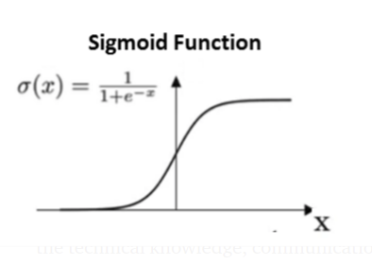

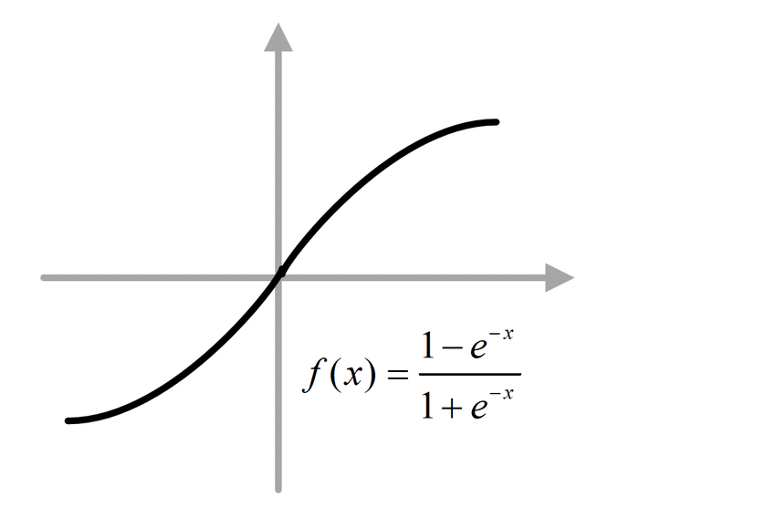

1. **McCulloch Pitts AND** - True/1 if both inputs are true/1, false/0 otherwise
2. **McCulloch Pitts ANDNOT** - True/1 if first input is true/1 and second input is false/0, otherwise false/0
3. **McCulloch Pitts XOR** - Can’t be represented by simple logic function / single layer neuron network. Needs intermediate neuron as well. 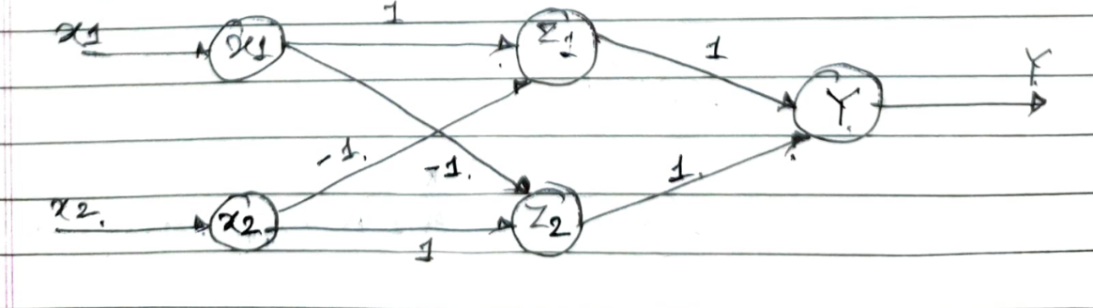**Yin = x1(x2)’ + (x1)’ x2** OR **z1 + z2** where **z1 = x1(x2)’** & **z2 = (x1)’ x2**
4. Make the truth table -> Take the inputs -> assume excitatory weights (w1=w2=1) -> calculate yin for each. If there is no other case where the neuron is fired except for when choosing inputs where output is 1 then threshold(theta) = yin is calculated using those inputs. Threshold >= nw - p (n = no of neurons w = excitatory wts, p = inhibitory wts only magnitude (= 0)). If there exists some other case then change the weights w1 =1, w2 = -1 (then p = 1) and check again -> Write the activation function y = f(yin) as per the threshold conditions.

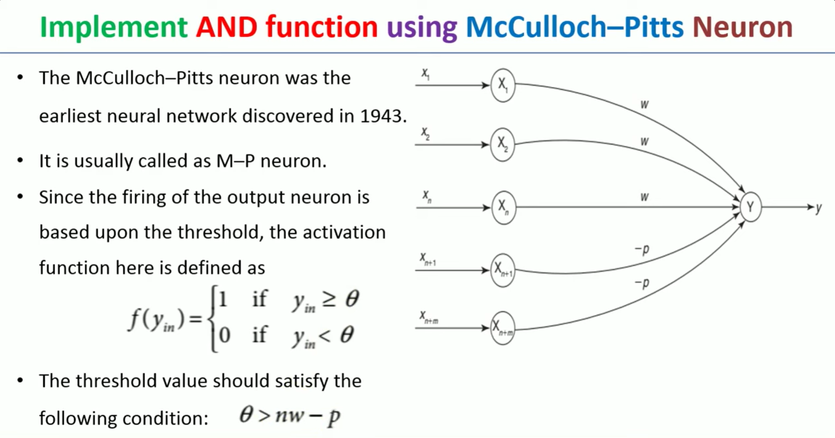

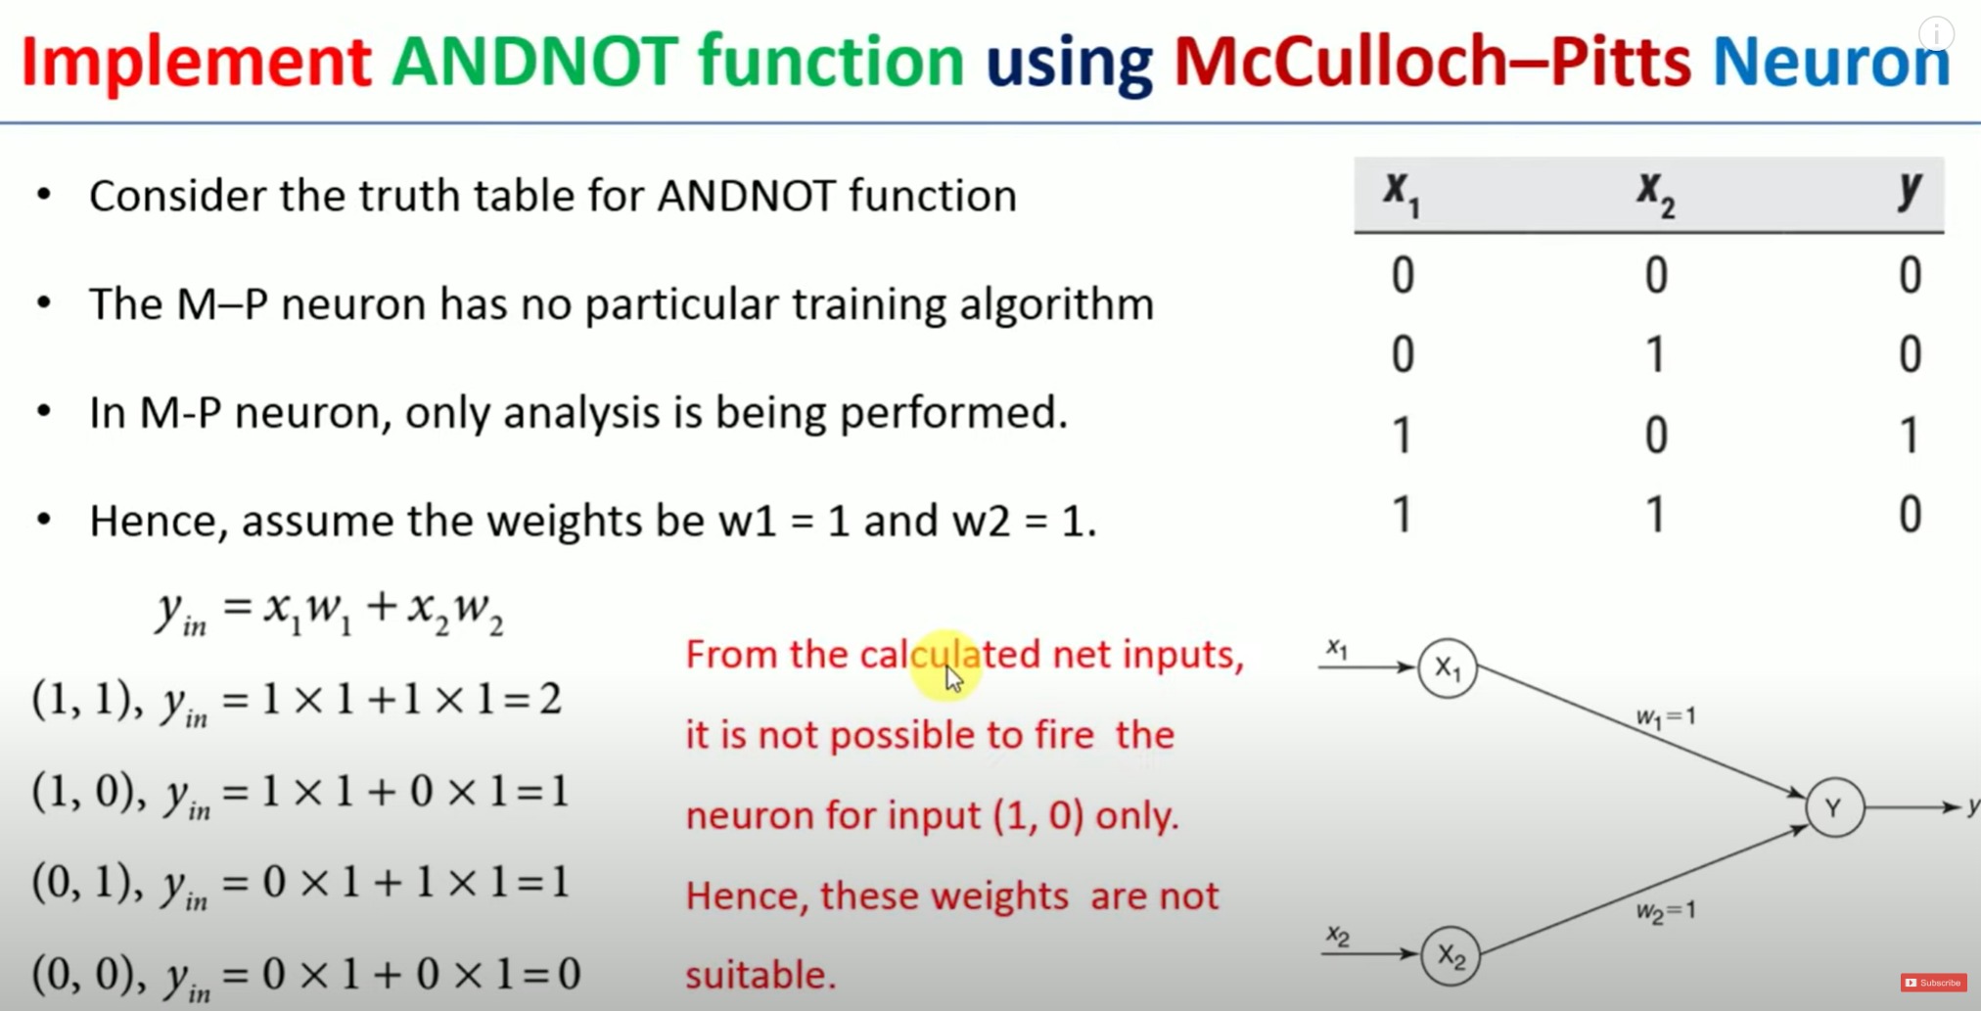

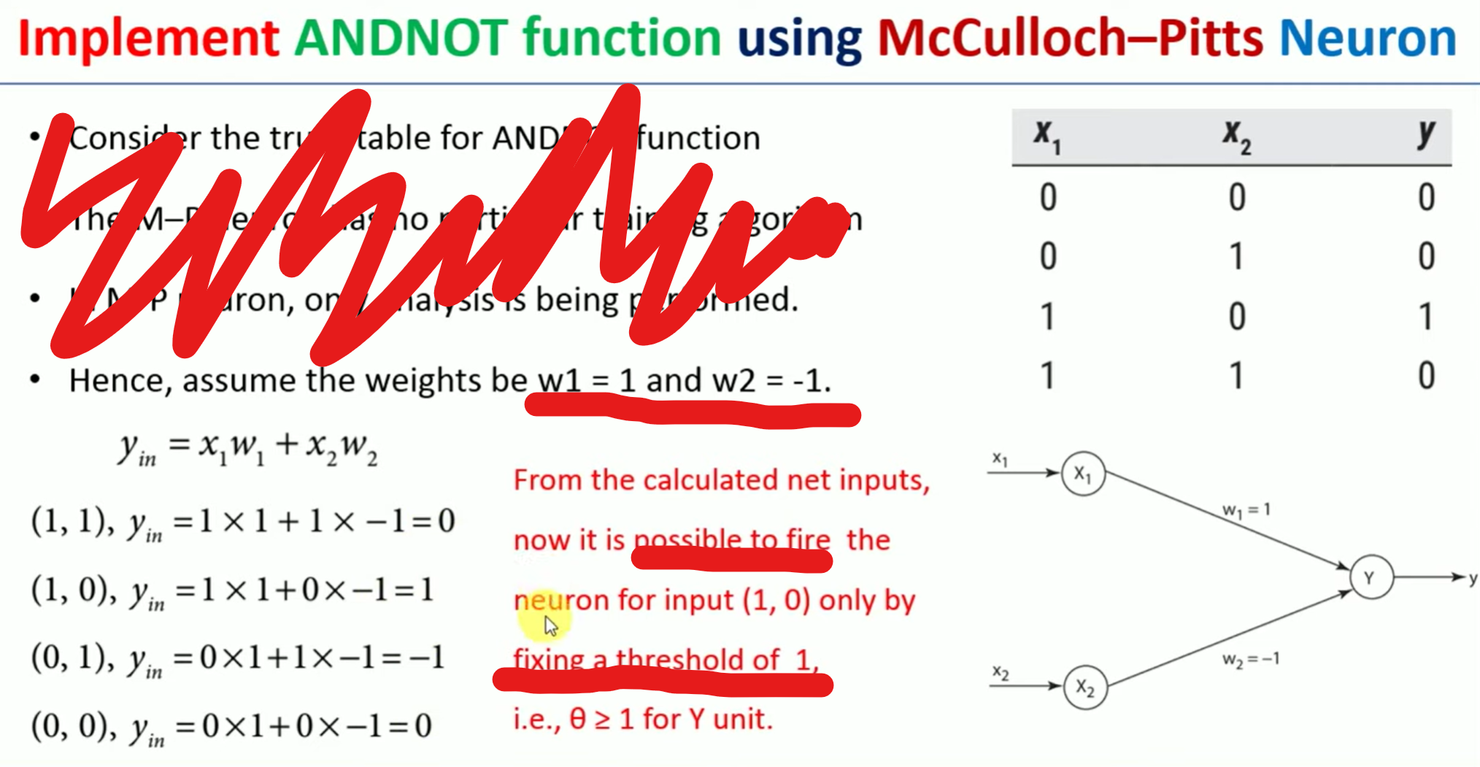

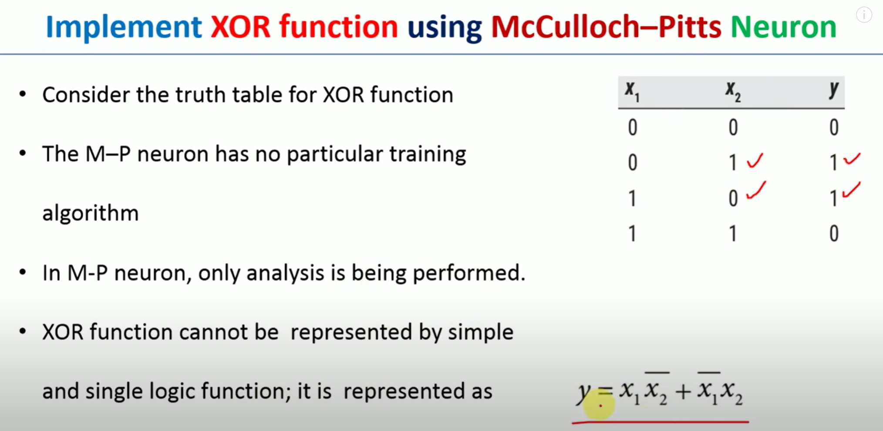

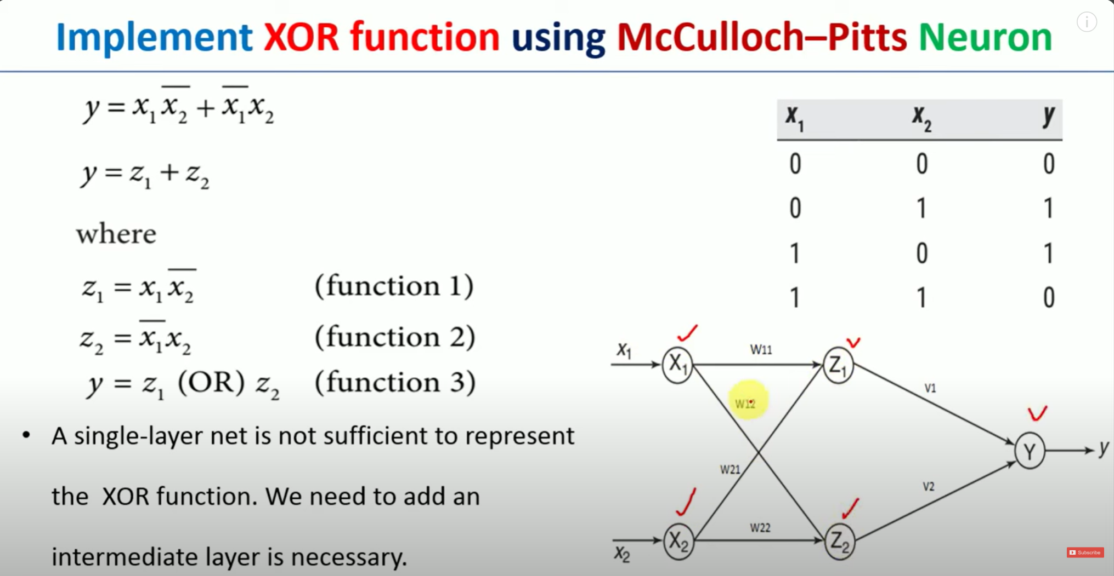

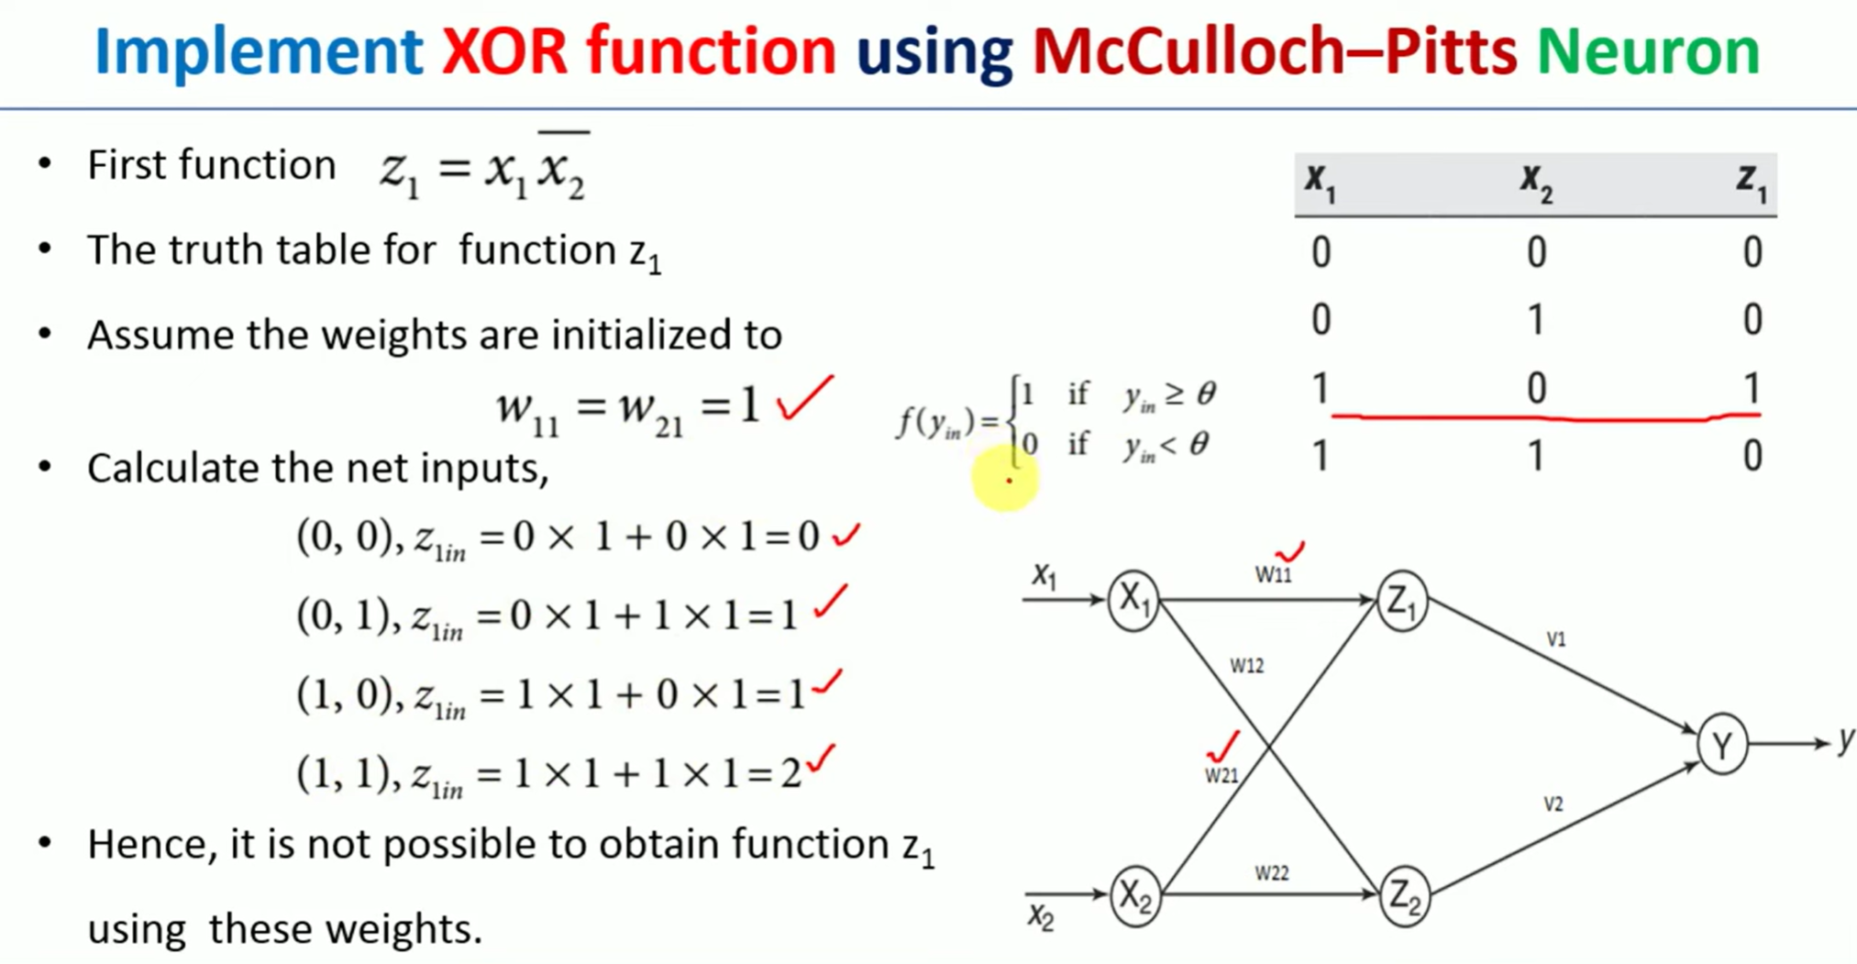

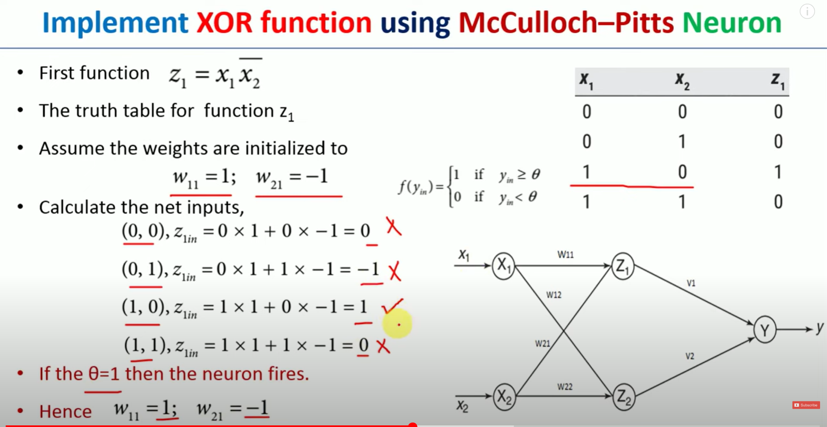

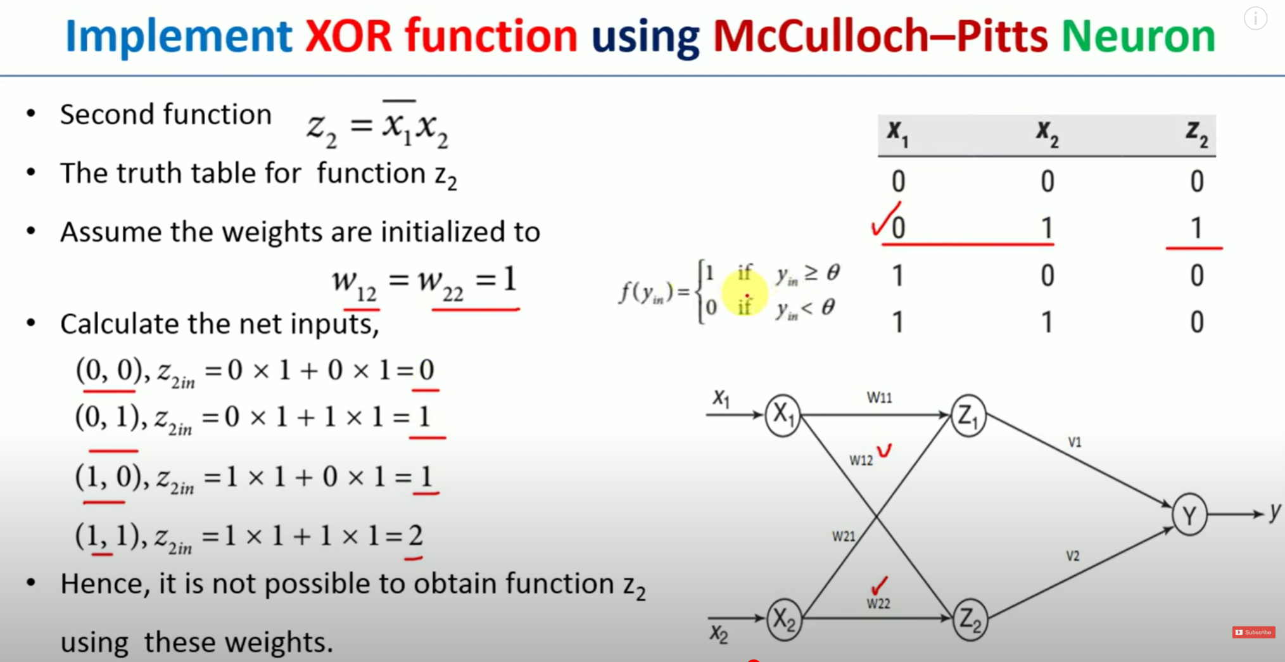

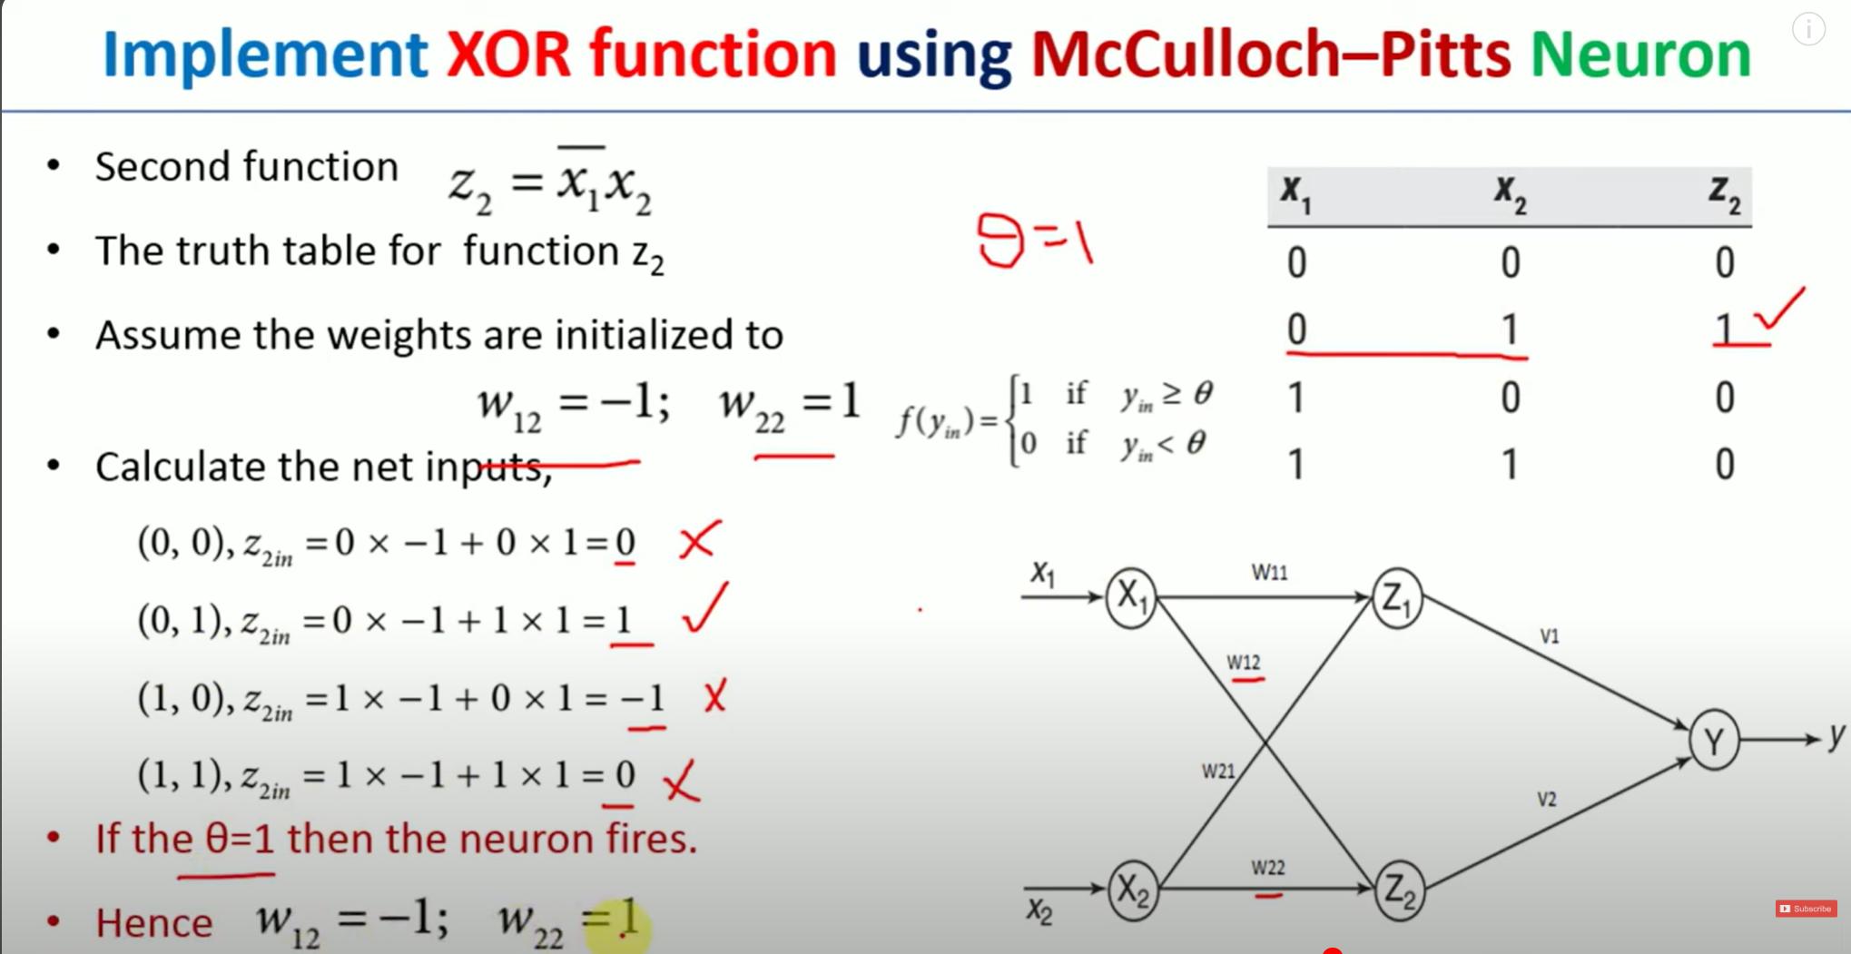

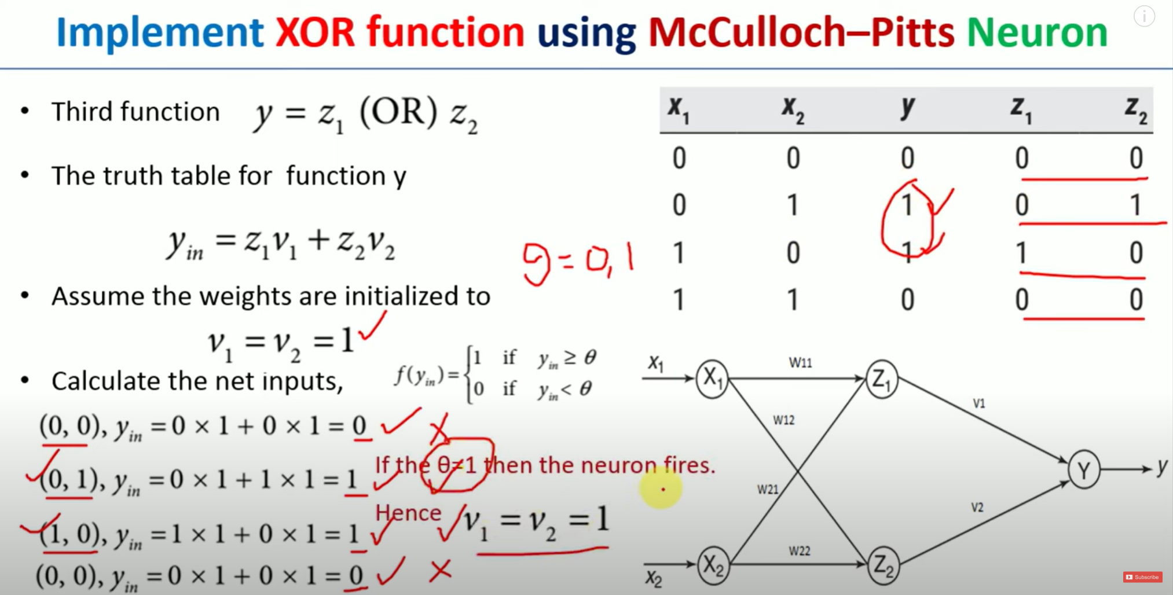

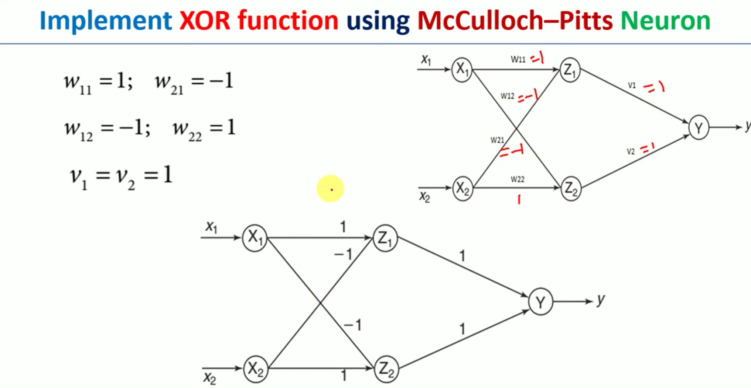

1. Hebb Network